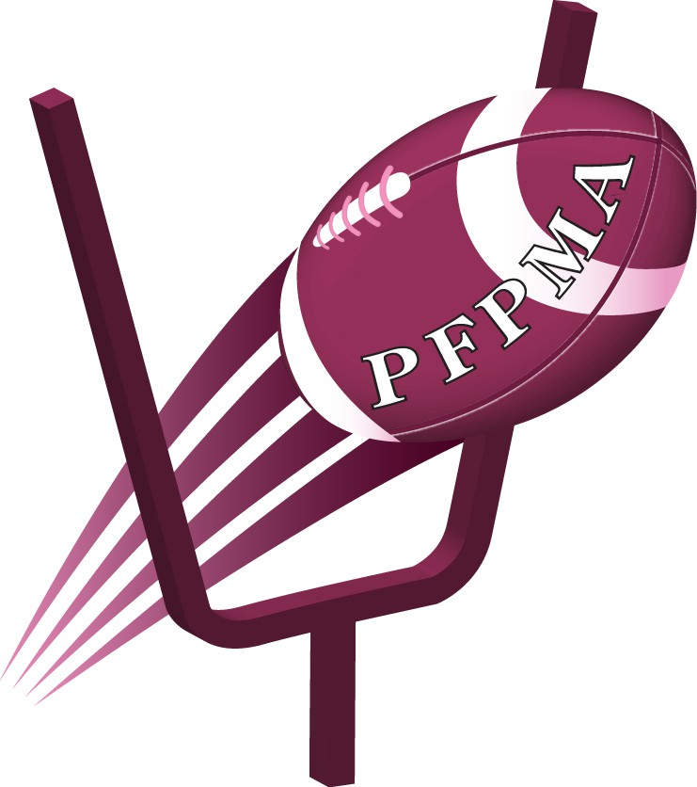

Professional Football Players Mothers Association
SPONSORSHIP PACKET

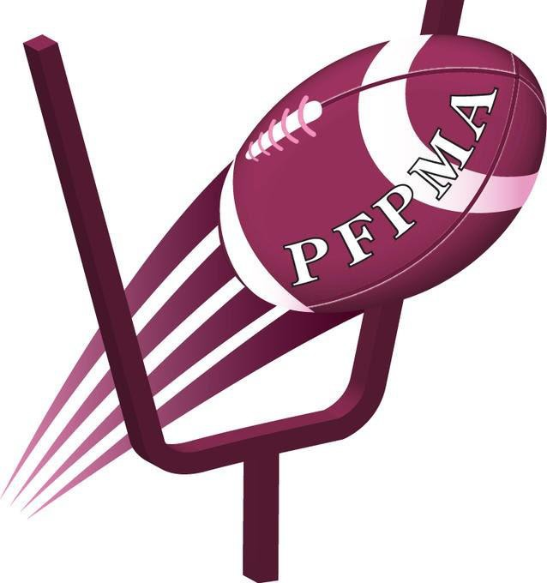

About PFPMA
The Professional Football Players Mothers Association (PFPMA) is delighted to host its 26th Annual Meeting (Preseason Conference) July 17-21 in Baltimore, Maryland. PFPMA is a charitable non- profit 501(C)3 organization comprised of mothers of both current and former professional football players. Our theme, "Where It All Started". PFPMA was birthed by some of the mothers of the Baltimore Ravens. The mothers developed a mechanism that provided education and support about the business of being a professional football player.

PFPMA actively promotes positive images of professional football players via the development and implementation of educational programs, community service and charitable donations throughout communities across the country. This year the charity PFPMA will be donating to Childhood Brain Cancer, Medulloblastoma, American Cancer Society, the contribution will enable the foundation to continue their work in the Baltimore City communities.

2 |

The highlight of the Conference and the primary source of our contribution is the Luncheon. The theme for the luncheon is "Unleash the Power of Your Potential". The luncheon will be held at the Renaissance Hotel in Baltimore Harbor.

Enclosed is a sponsorship package that illustrates the various opportunities to financially support the
Worthy and needed project for Baltimore City community.

If you have any immediate questions or
require additional information, please feel free to contact Michele Green, Conference Chairperson at
(609-638-6318).

Thanking you in advance for your support! Sincerely,
Michele Green
Preseason Conference Chairperson

The Professional Football Players Mothers Association a nonprofit
501c (3) service organization, all donations are tax deductible.

Sponsorship Levels
Hall of Fame Sponsors

$15,000
- PRINT, WEBSITE, ON-SITE, MARKETING & MEDIA RECOGNITION
- Logo on all event marketing materials
- Announcement of sponsorship on homepage of PFPMA website
- Logo Prominently displayed on the luncheon event page website
- Social Media announcement with logo
- Two (2) gala tables of 10 with premium seating and Table Sponsor signage
- Emcee introduction and recognition with presentation of a special keepsake
- Logo displayed as Hall of Fame Sponsor on Stage & Welcome sign
- Option to place marketing materials at registration table

All Pro Sponsors

$10,000

- PRINT, WEBSITE, ON-SITE, MARKETING & MEDIA RECOGINTION
- Logo on all event marketing materials
- Announcement of sponsorship on homepage of PFPMA website
- VIP gala table of 10 with premium seating and Table Sponsor signage
- Logo displayed as All Pro Sponsor on Stage &
Welcome sign
- Option to place marketing materials at registration table

3|

PFPMA Sponsorship
MVP
Sponsors

$5,000
  - PRINT, WEBSITE, ON-SITE, MARKETING & MEDIA RECOGNITION
  - Logo on all event marketing materials
  - Announcement of sponsorship on homepage of PFPMA website
  - VIP table of 10 with premium seating and Table Sponsor signage

Touchdown

$1,100
  - Table of 10 and Table Sponsor signage

Field Goal Sponsors Luncheon Tickets

$1,000 $125

4|

Our Mission
The Professional Football Players Mothers Association is a support system for the mothers of Professional football players. Our mission is to serve, support, educate, and strengthen our communities through charitable giving.

Our Vision
Transforming lives through serving, supporting, and strengthening our communities.

Our Motto
Service ----> Support ----> Success

CONTACT

PHONE EMAIL
609.638.6318
michelegreen@pfpma.org

WEBSITE WWW.PFPMA.ORG

5|

Sponsorship Reply Form

Return form & logo file to: michelegreen@pfpma.org

Select one:
Hall of Fame - $15,000
All Pro - $10,000 MVP - $5,000
__Touchdown - 1,100
Field Sponsors - $1,000

Extra Points – Friends of PFPMA $

Please mail check to:
Shelia Roberts
Professional Football Players Mothers
800 Hidden Lane
Knoxville, TN 37922

Company Name: Contact Person: Address: Phone: Email:

